LAB TASK #3
Q1. Write a program input two numbers, swap the values and then display them.
Solution:
#include<iostream>
using namespace std;
int main()
{
cout << "Muhammad Salman/nSAP Id:72373." << endl;
int n1, n2, n3, n4;
cout << "Enter your first number:" << endl;
cin >> n1;
cout << "Enter your second number:" << endl;
cin >> n2;
n3 = n2;
n4 = n1;
cout << "The values after swapping are below:" << endl;
cout << "Now first value is:\n" << n3 << endl;
cout << "Now second value is:\n" << n4 << endl;
return 0;
}
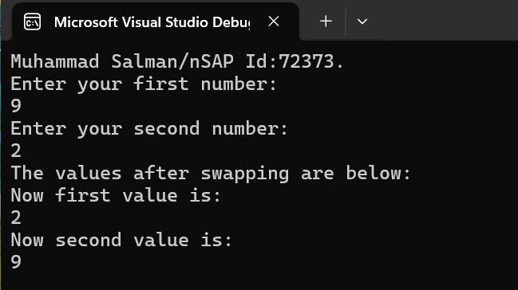

Q2. Write a program that input marks of three subjects, if the average of marks is more than 80 , it display two messages “You are above standard” and “Admission Granted”.
Solution:
#include <iostream>
using namespace std;
int main()
{
cout << "Muhammad Salman\nSAP Id:72373." << endl;
float m1, m2, m3, average;
cout << "Enter 3 subjects marks:" << endl;
cin >> m1>> m2>> m3;
average = m1 + m2 + m3 / 3;
if (average > 80) {
cout << "You are above standard.\nAdmission Granted" << endl;

}
return 0;
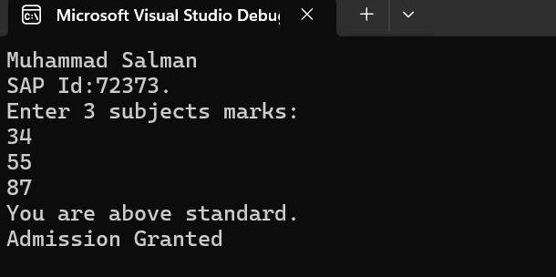
}
Q3. Write a program that input two numbers and finds if second number is square of first number.
Solution:
#include <iostream>
using namespace std;
int main()
{
cout << "Muhammad Salman\nSAP Id:72373." << endl;
int n1, n2;
cout << "Enter first number:" << endl;
cin >> n1;
cout << "Enter second number:" << endl;
cin >> n2;
if (n2 == n1 * n1) {
cout << "The second number is square of first number:" << endl;
}
else {
cout << "The second number is not the square of first number:" << endl;
}
return 0;
}
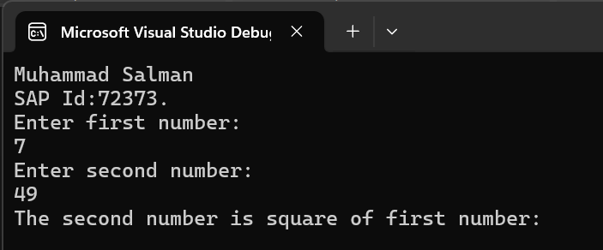

Q4. Write a program that input a number and find wheather the number is even or odd.
Solution:
#include <iostream>
using namespace std;
int main()
{
cout << "Muhammad Salman\nSAP Id:72373." << endl;
int n1;
cout << "Enter a Number:" << endl;
cin >> n1;
if ( n1%2==0) {
cout << "This number is even:" << endl;
}
else {
cout << "This number is odd:" << endl;
}
return 0;
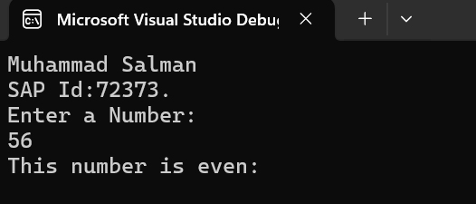
}

Q5. Write a program that input a number and determine it is positive , negative or 0.
Solution:
#include <iostream>
using namespace std;
int main()
{
cout << "Muhammad Salman\nSAP Id:72373." << endl;
int n1;
cout << "Enter a number:" << endl;
cin >> n1;
if (n1 > 0) {
cout << "This number is POSITIVE." << endl;
}
else if (n1 < 0) {
cout << "This number is NEGATIVE." << endl;
}
else {
cout << "This number is ZERO." << endl;
}
return 0;
}
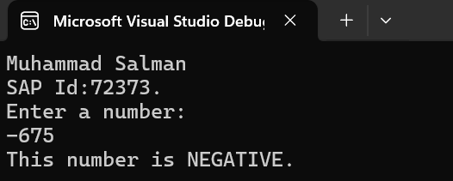

Q6: Write a program that input three numbers and display maximum number.
Solution:
#include<iostream>
using namespace std;
int main() {
cout << "Muhammad Salman\nSAP Id:72373." << endl;
int n1, n2, n3;
cout << "Enter three numbers:" << endl;
cin >> n1 >> n2 >> n3;
if (n1 > n2) {
if (n1 > n3)
cout << "Maximmum number is:" << n1 << endl;
else
cout << "Maximmum number is:" << n3 << endl;

}
else {
if (n2 > n3)
cout << "Maximum number is:" << n2 << endl;
else
cout << "Maximum number is:" << n3 << endl;
}
return 0;
}
